ENERGY RESEARCH GOES MAINSTREAM
WHEN SCIENTIFIC JOURNALISTS MEET ENERGY RESEARCHERS
RELATE project

Date: Tuesday 26/03/2010
Hour: 14.00 -16.30
Location: TÜBİTAK Marmara Research Center Energy Institute

Europe has been producing some ground-breaking research in the energy fields. But how this research is communicated? What are the efforts and links that can improve the transfer of information?
RELATE (Research Laboratories for Teaching journalists) is a pilot project conceived to bridge relations between researchers in EU funded activities and journalists, setting a potential basis for long-lasting interactions. The expected outcome is an amplification of the stories-to-tell offered by scientific research and raising social awareness on the ongoing activities that are bringing innovation to the EU and the world.

In this workshop, the RELATE actors, researchers and journalists will present their experience and efforts carried out in a special week experience and will give their views on the efforts that can improve the transfer of information between researchers and journalists.

The workshop is held on the last day of the training week during which 8 journalists from different countries spend in a research laboratory of the Marmara Research Centre, within the framework of RELATE project, and will be an occasion for them to meet and openly discuss with the public about this unique experience.

The workshop will be an opportunity for researchers and for the media attending to discuss together on how to set up cooperation framework with the aim of improving the current situation of connecting relevant EU research to the mainstream and specialised media.

RELATE is a project funded by the European Commission under FP7 of research and development programme with the Science in Society Programme. For more information on the project, visit: http://relateproject.eu

Programme of the event:

14:00 – 14.20 Registration and welcome coffee

14:20 – 14.30 Introduction to the workshop: Ms. Gülnihal Ergen TUBITAK, partner of RELATE

14.30 – 14.50 “Energy Research in the Past, Present and Future” – Speech from Assoc. Prof. Mustafa Tırıs, Director of the Energy Institute

14.50 – 15.10 “Communicating Science” – Speech from Assoc. Prof. Halil Nalçaoğlu, Coordinator of the Media and Communication Systems Program, İstanbul Bilgi University

15.10 – 15.30 A perspective from the Energy Researchers– The researchers from the Institute will talk about their efforts in terms of communication, about the experience of the week with professional journalists and how they see their future communication: wishes and concrete efforts to be undertaken. It will also be an opportunity to further communicate their research results and/or innovation towards the mainstream and specialised media attending the event

15.30 – 16.00 Young journalists talking about Energy Research - The 4 journalists taking part in the week training will discuss about their experiences and show the difficulties and suggestions for improving the dialogue on research to the public

16.00 – 16.30 Open discussion with researchers, journalists and communication experts to plan concrete action for future of research communication. Is it a question of field or research at general level faces these issues? Other researchers from the Institute will intervene in the debate with best and worst practices

For further information, contact

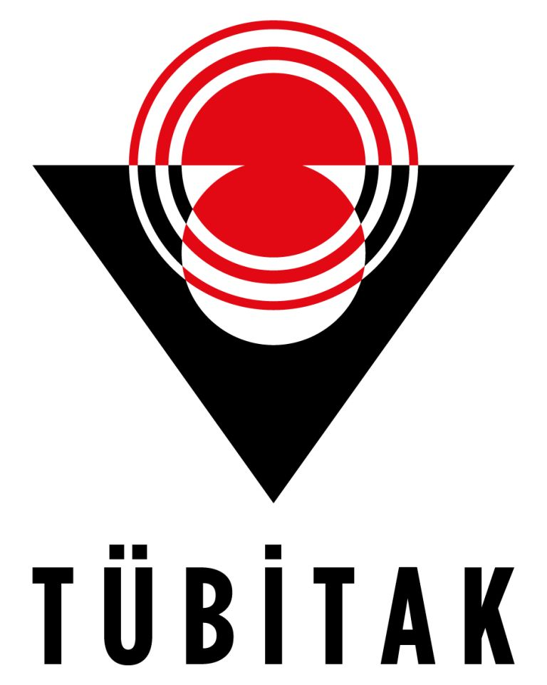
RELATE contact in Turkey
Ms. Gülnihal Ergen
TÜBİTAK, Ankara, Turkey
gulnihal.ergen@tubitak.gov.tr
Tel. +90 312 468 5300/1253

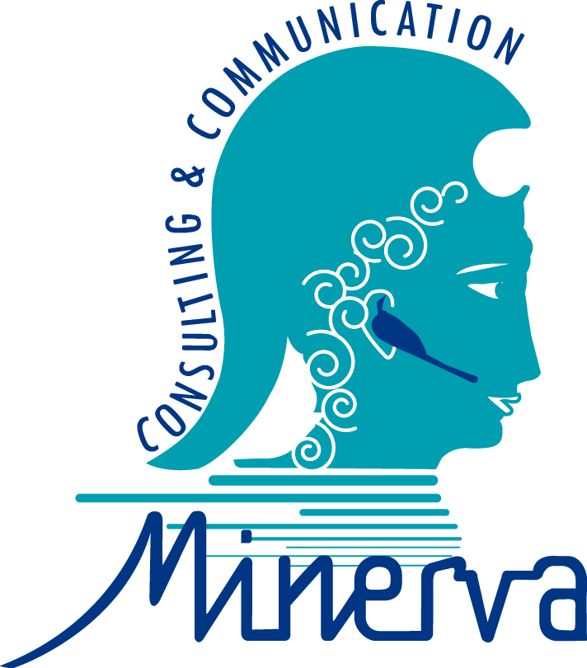
RELATE project coordinator
Ms. Hinano Spreafico
MINERVA Consulting & Communication Sprl., Brussels, Belgium
hinano@minerva-communication.eu
Tel. +32 2 544 1888

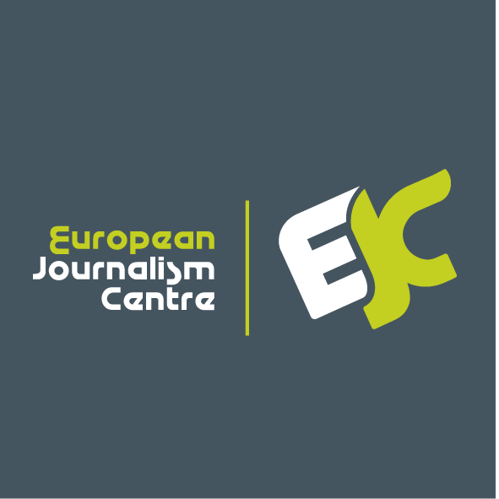
RELATE media contact
Mr. Howard Hudson
European Journalism Centre, Maastricht, The Netherlands
hudson@ejc.net
Tel. +31 433 254030

